MINI PROJECT REPORT
ON
“Quiz Game”

Submitted in the partial fulfilment for the award of a degree of
Bachelor of Computer Application



UTTARANCHAL UNIVERSITY
Bachelor of Computer Application
School of Computing Sciences
Session (2025-2026)

Under the supervision of: Submitted By:
Mr. Deepak Kumar Mitul saini
Assistant Professor BCA I-C

I

ACKNOWLEDGEMENT

The most awaited moment of any endeavour is successful completion, but nothing can be done successfully if done alone. Success is the outcome of contribution and consistent help of various persons and I thank those ones
who helped me in successful completion of this project.

Primarily, I would like to thank Prof. Sonal Sharma, Director of USCS for providing a healthy and encouraging environment to study.

Secondly, I would like to thank Prof.. Sameer Dev Sharma, HOD USCS.

I express my thanks to Mr. Deepak kumar, Project Mentor, and Assistant Professor USCS. She has been generous enough to provide me an opportunity and accepting my candidature for the most valuable guidance and support given at every stage to boost my morale.

Mitul Saini BCA II-C

DECLARATION

I hereby declare that the project report titled “Quiz Game” is submitted by, Tanish Panwar, to Uttaranchal School of Computing Sciences. The project was done under the guidance of Mr. Deepak kumar, Assistant Professor, USCS. I further declare that the work reported in this project has not been submitted, either in part or in full, for the award of any other degree or diploma in this University or any other University or Institute.

Mitul saini BCA II-C

CERTIFICATEOF ORIGINALITY

This is to certify that the project entitled “Quiz Game” mitul saini , has been submitted in the partial fulfilment of the requirements for the award of the degree of Bachelor of Computer Application from Uttaranchal University, Dehradun. The results embodied in this project have not been submitted to any other University or Institution for the record of any degree.

Under the supervision of:
Mr. Deepak Kumar
Assistant Professor
(USCS)

IV
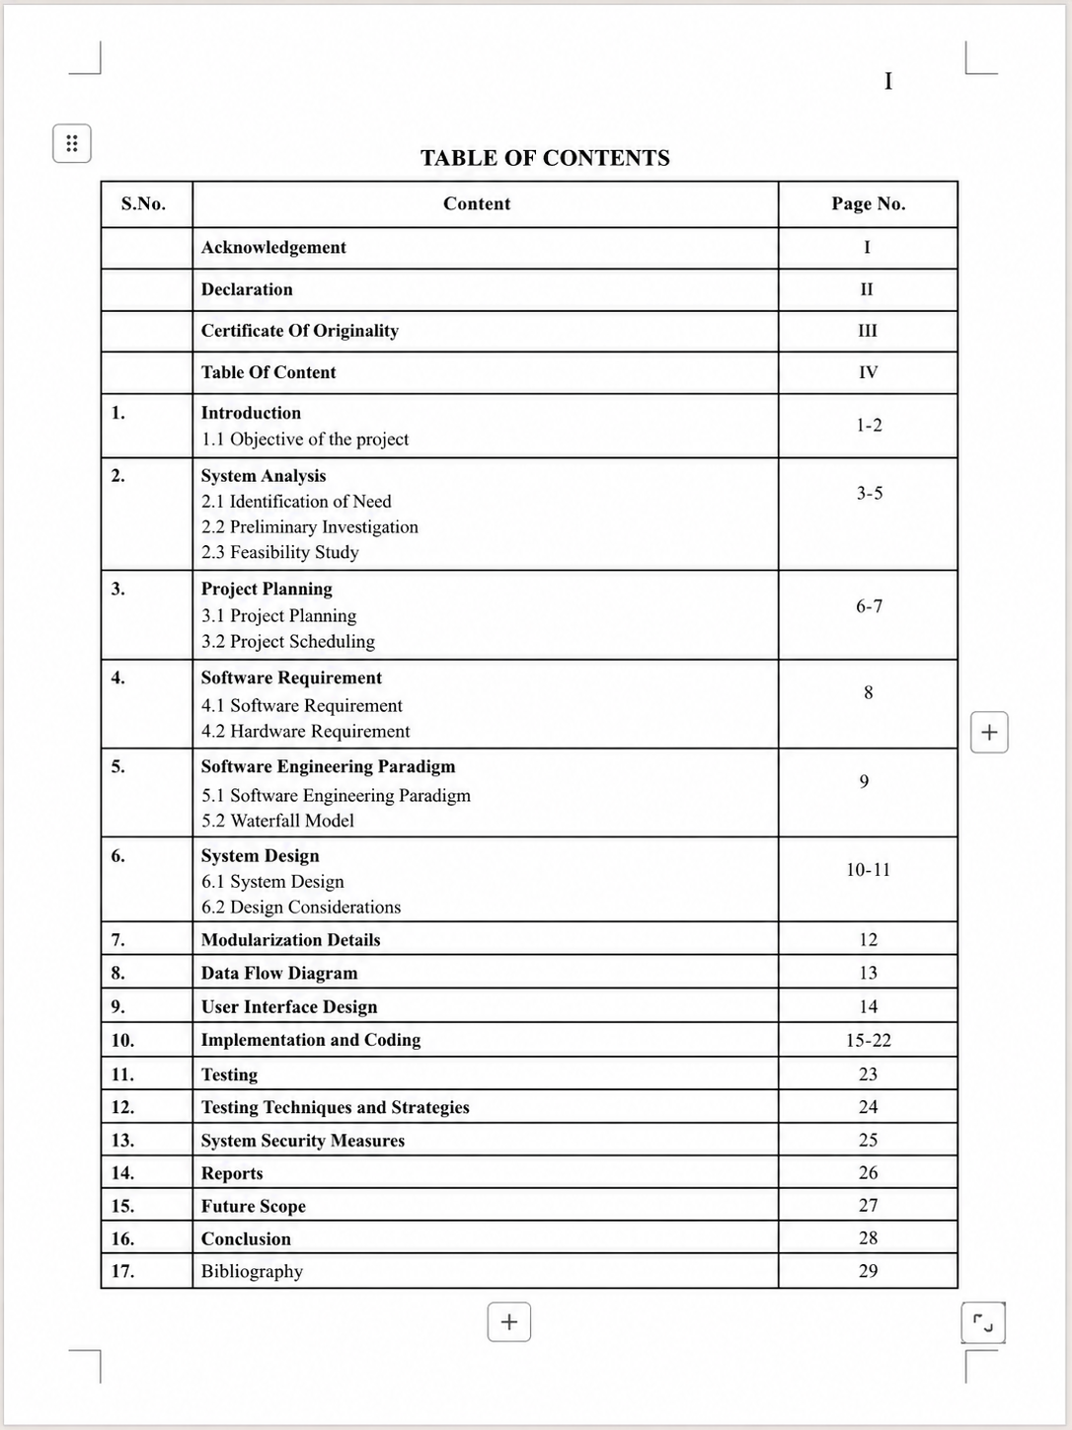

Introduction.

The Quiz Game in C is a simple console-based application developed using the C programming language. This project is designed to ask questions to the user and evaluate their answers based on correctness.
For example, the system asks a question like:
Who is the developer of C language?
The user enters the answer:
Dennis Ritchie
The program checks whether the answer is correct or incorrect. After all the questions are completed, the system calculates the total score and displays how many answers were correct and how many were wrong.
This project helps students understand the practical use of C programming concepts such as loops, conditional statements, strings, functions, arrays, and user input handling. It is a beginner-friendly project that improves programming logic and problem-solving skills.
The Quiz Game project is useful for learning purposes and can also be used in schools, colleges, and training programs to test knowledge in an interactive way.

Objective of the project

The main objectives of the Quiz Game in C project are:
- To develop a simple quiz game using C programming language
- To understand the use of loops and conditional statements
- To implement answer checking and score calculation
- To improve programming logic and problem-solving skills
- To create an interactive and educational application
- To help users test their general knowledge in a simple way
This project provides practical experience in building a real application using basic programming concepts.

System Analysis
System analysis is the process of studying the requirements and structure of the project before development begins.
In the Quiz Game project, the system requires a set of predefined questions and correct answers stored in the program. The system should display questions one by one, accept user input, compare answers, calculate the score, and show the final result.
The analysis focuses on creating a simple, fast, and user-friendly quiz system that works accurately without errors. It also ensures that the program can handle invalid inputs and maintain proper score calculation.
System analysis helps in understanding how the quiz system should work efficiently.

Identification of Need
In today’s education system, interactive learning methods are becoming more important. Traditional learning methods are often less engaging for students.
The Quiz Game in C project is needed to provide a simple and effective way of testing knowledge through questions and answers. It helps users learn while playing and improves memory and understanding.
This project is useful in schools, colleges, and competitive exam preparation where quizzes are commonly used. It also helps beginners in learning programming concepts through a practical application.
Thus, this project fulfills the need for a basic educational and interactive quiz system.

Preliminary Investigation
Preliminary investigation is the first step where the problem and basic requirements are studied.
In this project, the main problem is creating a system that can ask questions, accept answers, and calculate the score automatically.
The investigation shows that manual quiz checking takes more time and effort. A computerized quiz system can make the process faster and more accurate.
The study confirms that C programming is suitable for developing this project because it supports input handling, conditional statements, loops, and score calculation easily.
This investigation proves that the Quiz Game project is practical and useful.

Feasibility Study
Feasibility study helps in checking whether the project can be developed successfully.

Technical Feasibility
The project is technically feasible because it uses basic C programming concepts such as loops, if-else conditions, strings, and functions. No advanced technology is required.

Economic Feasibility
The project is economically feasible because it only requires a computer and basic C compiler software like Turbo C, Dev C++, or Code::Blocks.

Operational Feasibility
The system is simple to use and understand. Users can easily answer questions and view their results without difficulty.
Thus, the project is feasible from technical, economic, and operational points of view.

Project Planning

Project planning is the process of organizing all activities needed for successful project completion.
For the Quiz Game project, planning includes selecting the topic, understanding requirements, preparing the flowchart, writing the code, testing the system, and preparing the final report.
The project is divided into small steps so that development becomes easy and systematic. Proper planning reduces mistakes and saves time.
The goal of project planning is to complete the project successfully within the given time and resources.

Project Scheduling
Project scheduling helps in managing time for each phase of the project.

Schedule of Work

Week 1
Topic selection and requirement analysis

Week 2
System study and flowchart preparation

Week 3
Program coding and implementation

Week 4
Testing and debugging

Week 5
Documentation and report writing

Week 6
Final review and project submission
This schedule helps in completing the project step by step without confusion

Software Requirement Specification (SRS)

The software required for this project includes:
- C Programming Language
- Turbo C / Dev C++ / Code::Blocks
- Windows Operating System
- Text Editor for documentation
- C Compiler for program execution
These software tools are necessary for writing, compiling, testing, and running the Quiz Game project successfully.

Software Engineering Paradigm
Software engineering paradigm refers to the structured method used for developing software systems.
In the Quiz Game project, the Waterfall Model is the most suitable software engineering paradigm because the project follows a step-by-step development process.
The stages include:
- Requirement Analysis
- System Design
- Coding
- Testing
- Implementation
- Maintenance
Each stage is completed before moving to the next stage. This makes the development process simple, organized, and easy to manage.
Using the Waterfall Model helps in reducing errors and improving project quality.

Modularization Details
The project is divided into different modules so that each part performs a specific task independently.

1. Welcome Module
This module displays the welcome message and instructions of the quiz game.

2. Question Module
This module stores and displays quiz questions one by one to the user.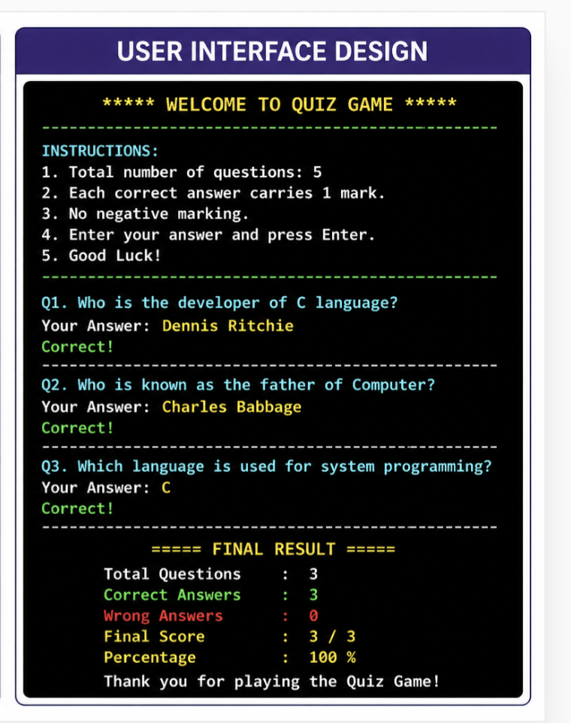

3. Answer Input Module
This module accepts answers entered by the user.

4. Answer Checking Module
This module compares the user’s answer with the correct answer.

5. Score Caulation Module
This module updates the score based on correct answers.x

6. Result Display Module
This module shows the final score, correct answers, and wrong answers.
Modularization helps in better understanding, easy debugging, and smooth execution of the project.

System Design

System design is the process of creating the structure of the project before coding begins.In the Quiz Game in C project, the system is designed to ask questions to the user, check answers, and calculate the final score.The system starts by displaying a welcome message and instructions. Then it asks questions one by one. The user enters the answer, and the program compares it with the correct answer stored in the system.If the answer is correct, marks are added to the score. If the answer is wrong, the program moves to the next question. After all questions are completed, the final result is displayed showing the total score, correct answers, and wrong answers.This design makes the system simple, efficient, and easy to use.

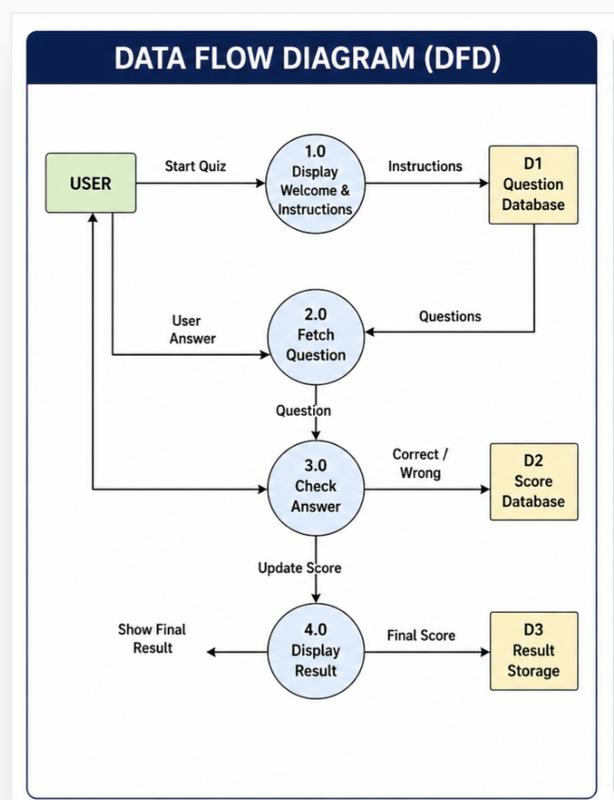

User Interface Design



Appendix: C Program for Quiz Game

#include <stdio.h>
int main() {
int score = 0;
char ans;
printf("===== C Programming Quiz =====\n\n");
// Question 1
printf("1. Who developed C language?\n");
printf("a) James Gosling\n");
printf("b) Dennis Ritchie\n");
printf("c) Bjarne Stroustrup\n");
printf("d) Guido van Rossum\n");
printf("Enter your answer: ");
scanf(" %c", &ans);
if (ans == 'b' || ans == 'B') {
score++;
}
// Question 2
printf("\n2. Which symbol is used for comments in C?\n");
printf("a) //\n");
printf("b) <!-- -->\n");
printf("c) #\n");
printf("d) %%\n");
printf("Enter your answer: ");
scanf(" %c", &ans);

if (ans == 'a' || ans == 'A') {
score++;
}
// Question 3
printf("\n3. Which function is used to print output in C?\n");
printf("a) print()\n");
printf("b) echo()\n");
printf("c) printf()\n");
printf("d) cout<<\n");
printf("Enter your answer: ");
scanf(" %c", &ans);
if (ans == 'c' || ans == 'C') {
score++;
}
// Question 4
printf("\n4. Which header file is required for printf()?\n");
printf("a) stdlib.h\n");
printf("b) conio.h\n");
printf("c) math.h\n");
printf("d) stdio.h\n");
printf("Enter your answer: ");
scanf(" %c", &ans);
if (ans == 'd' || ans == 'D') {
score++;
}

// Question 5
printf("\n5. Which loop is used when number of iterations is known?\n");
printf("a) while\n");
printf("b) do-while\n");
printf("c) for\n");
printf("d) switch\n");
printf("Enter your answer: ");
scanf(" %c", &ans);

if (ans == 'c' || ans == 'C') {
score++;
}

printf("\n===== RESULT =====\n");
printf("Your Score: %d/5\n", score);

if (score == 5)
printf("Grade: Excellent!\n");
else if (score >= 3)
printf("Grade: Good!\n");
else
printf("Grade: Needs Improvement\n");

return 0;
}

Testing
Testing is the process of checking whether the project works correctly and produces accurate results.
In this project, testing ensures that:
- Questions are displayed properly
- User input is accepted correctly
- Answers are checked accurately
- Score calculation is correct
- Final result is displayed properly
- Invalid inputs are handled safely
Testing helps in removing errors and improving the quality of the project.

Testing Techniques and Strategies
Different testing methods are used to verify the system.

Unit Testing
Each module such as question display, answer checking, and score calculation is tested separately.

Integration Testing
All modules are tested together to ensure smooth functioning of the complete quiz game.

System Testing
The entire system is tested by running the full quiz and checking final results.

Validation Testing
This testing ensures that correct answers increase score and wrong answers do not.

Error Handling Testing
The system is tested for invalid or empty inputs to avoid program failure.
These testing strategies improve the reliability and correctness of the quiz system.

System Security Measures
Although this is a simple project, some security measures are important.
The system ensures that:
- Correct answers are stored safely in the program
- User input is handled properly
- Invalid inputs do not crash the system
- Score calculation remains accurate
- Quiz data is protected from accidental changes
These measures improve system stability and prevent errors during execution.

Reports
The system generates a final report after the quiz is completed.
The report includes:
- Total number of questions
- Number of correct answers
- Number of wrong answers
- Final score
- Performance result (Pass/Fail if required)
This report helps users understand their performance and makes the quiz more useful for learning purposes.

Future Scope

The Quiz Game in C project can be improved further in the future.
Possible future improvements include:
- Multiple choice questions (MCQ) support
- Timer-based quiz system
- Difficulty levels (Easy, Medium, Hard)
- Graphical User Interface (GUI)
- Database storage for questions and scores
- Online multiplayer quiz system
These features can make the project more advanced, interactive, and useful for real educational applications.

Conclusion
The Quiz Game in C is a simple and interactive project developed to test user knowledge through questions and answers. This project successfully uses basic C programming concepts such as loops, conditions, arrays, functions, and input handling.
The system can display questions, accept answers, calculate scores, and show final results accurately. It is useful for learning, educational activities, and improving programming skills.
This project helped in understanding practical implementation of C language concepts in real applications. In future, more advanced features like timer, GUI, and database can be added to improve the system further.

Bibliography

- Programming in ANSI C – E. Balagurusamy
- Let Us C – Yashavant Kanetkar
- C Programming Absolute Beginner’s Guide
- Data Structures Using C – Reema Thareja
- www.geeksforgeeks.org
- www.tutorialspoint.com
- C Programming Notes by College Faculty

Thank You !

